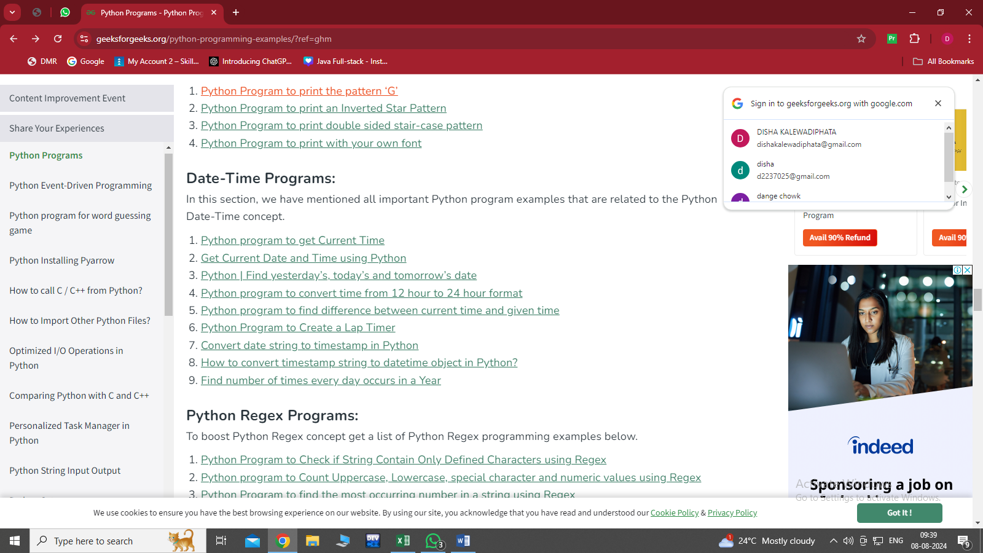**DATE AND TIME ASSIGNMENT**

SOLUTIONS-

**Example 1: Current time of a timezone – Using pytZ module**

from datetime import *

import pytz

tz_INDIA = pytz.timezone('Asia/Kolkata')

datetime_INDIA = datetime.now(tz_INDIA)

print("INDIA time:", datetime_INDIA.strftime("%H:%M:%S"))

**Example 2 : Current time – Using date time object**

from datetime import datetime

# now() method is used to

# get object containing

# current date & time.

now_method = datetime.now()

# strftime() method used to

# create a string representing

# the current time.

currentTime = now_method.strftime("%H:%M:%S")

print("Current Time =", currentTime)

**Example 3:Python program to find yesterday,today and tomorrow**

# Import datetime and timedelta

# class from datetime module

from datetime import datetime, timedelta

# Get today's date

presentday = datetime.now() # or presentday = datetime.today()

# Get Yesterday

yesterday = presentday - timedelta(1)

# Get Tomorrow

tomorrow = presentday + timedelta(1)

print("Yesterday = ", yesterday.strftime('%d-%m-%Y'))

print("Today = ", presentday.strftime('%d-%m-%Y'))

print("Tomorrow = ", tomorrow.strftime('%d-%m-%Y'))

**Example 4:** **Python program to convert time from 12 hour to 24 hour format**

# Function to convert the date format

def convert24(str1):

# Checking if last two elements of time

# is AM and first two elements are 12

if str1[-2:] == "AM" and str1[:2] == "12":

return "00" + str1[2:-2]

# remove the AM

elif str1[-2:] == "AM":

return str1[:-2]

# Checking if last two elements of time

# is PM and first two elements are 12

elif str1[-2:] == "PM" and str1[:2] == "12":

return str1[:-2]

else:

# add 12 to hours and remove PM

return str(int(str1[:2]) + 12) + str1[2:8]

print(convert24("08:05:45 PM"))

**EXAMPLE 5:Python program to find the difference between two times**

# function to obtain the time in minutes form

def difference(h1, m1, h2, m2):

# convert h1 : m1 into

# minutes

t1 = h1 * 60 + m1

# convert h2 : m2 into

# minutes

t2 = h2 * 60 + m2

if (t1 == t2):

print("Both are same times")

return

else:

# calculating the difference

diff = t2-t1

# calculating hours from

# difference

h = (int(diff / 60)) % 24

# calculating minutes from

# difference

m = diff % 60

print(h, ":", m)

# Driver's code

if __name__ == "__main__":

difference(7, 20, 9, 45)

difference(15, 23, 18, 54)

difference(16, 20, 16, 20)

**EXAMPLE 6:** **Python Program to Create a Lap Timer**

# importing libraries

import time

starttime = time.time()

lasttime = starttime

lapnum = 1

print("Press ENTER to count laps.\nPress CTRL+C to stop")

try:

while True:

# Input for the ENTER key press

input()

# The current lap-time

laptime = round((time.time() - lasttime), 2)

# Total time elapsed

# since the timer started

totaltime = round((time.time() - starttime), 2)

# Printing the lap number,

# lap-time and total time

print("Lap No. "+str(lapnum))

print("Total Time: "+str(totaltime))

print("Lap Time: "+str(laptime))

print("*"*20)

# Updating the previous total time

# and lap number

lasttime = time.time()

lapnum += 1

# Stopping when CTRL+C is pressed

except KeyboardInterrupt:

print("Done")

**EXAMPLE 7:** **# Python program to convert date to timestamp**

import time

import datetime

string = "20/01/2020"

print(time.mktime(datetime.datetime.strptime(string,"%d/%m/%Y").timetuple()))

**EXAMPLE 8: How to convert timestamp string to date time object in Python?**

from datetime import datetime

timestamp_string = "2023-07-21 15:30:45"

format_string = "%Y-%m-%d %H:%M:%S"

datetime_object = datetime.strptime(timestamp_string, format_string)

print(datetime_object)